APDLib
User Guide
(Application Programming Interface
(API)
for
APDCAM)

Version 2.6

21 July, 2016

Copyright © Fusion Instruments Kft. 2016

Contents
1. Introduction 3
2. Programming language and target operating system 3
3. Overview of functions 4
4. Using APDLib 5
5. The APDLib library 8
5.1 Initiating and closing APDLib 8
5.2 Searching for APDCAMs in an IP address range 8
5.3 Opening and closing APDCAM 9
5.4 Self test 11
5.5 Changing the IP address of the camera 11
5.6 Setting the ADC timing 11
5.7 Setting the signal offsets 13
5.8 Calibrating the offset 14
5.9 Setting up the digital filter 14
5.10 Allocating memory for measurements 15
5.11 Preparing for the measurement 17
5.12 Setting the trigger conditions 17
5.13 The measurement 19
5.14 Shutter control 21
5.15 Calibration light control 22
5.16 Setting and monitoring the detector bias voltage 22
5.17 Setting and controlling the detector temperature 23
5.18 Setting and monitoring analog panel power 25
5.19 Setting camera fans speed 26
5.20 Setting the overload protection 26
5.21 Using ADC test pattern 27
5.22 Reading the system status 28
6. Troubleshooting 31

Contents

Introduction

APDCAM is an Avalanche Photodiode (APD) detector camera developed for low light and high speed applications by Fusion Instruments Kft. This document describes the Application Programming Interface (API) of APDCAM. For a detailed description of APDCAM refer to its User's Guide.
Additionally to the set of C functions the APDCAM API also contains a scriptable test program which serves as an example but can also be used to perform routine measurement tasks.

Programming language and target operating system
APDLib is written in C++ for Windows XP, Windows 7, 8, 8.1, 10 and for Linux operating systems.. It was tested in Qt 5.6.1 Framework with GCC 64bit and MSVC 2013 64bit compiler on both windows and linux.
The Windows kit contains a static library APDLib.lib, header files and the source code of the APDTest test program. Solution and project files for MS Visual Studio are also supplied. The source code of APDLib.lib is not made public.
The linux kit contains a static library APDLib.a. Both all packages contains header files and the source code of the APDTest test program. The project files for QtCreator are also supplied. The source code of APDLib is not made public.
For memory allocation the Lock Pages in Memory option should be enabled in Windows Control Panel. This can be done by opening “Local Security Policy” in the XP Control Panel (in Administrative Tools under Windows 7, 8, 8.1 and 10). In the “Local Policies -> User Rights Assignments” panel click “Lock pages in memory” with the right mouse button and select “Properties” from the menu. Add the user to the list who is going to run the data acquisition program and reboot the computer. On the executables the user must enable the “Run in administrator mode” to ensure the API will have the rights to all the resources it needs. This can be done by right clicking on the executable, select “Properties” menu item, go to the “Compatibility” tab and on the bottom, tick “Run this program as an administrator”, click Apply and OK. After this was set, Windows will run the software in administrator mode every time.

Overview of functions

Function | Description
APDCAM_Allocate() | Allocates memory for measurement.
APDCAM_Arm() | Prepares the measurement.
APDCAM_Calibrate() | Calibrates the offset.
APDCAM_Close() | Closes APDCAM.
APDCAM_DataMode() | Sets ADC test patterns instead of measured data.
APDCAM_Find() | Scans a range of IP addresses to find APDCAM devices.
APDCAM_GetADCOffsets() | Reads the signal offsets.
APDCAM_GetAnalogPower() | Gets the current status of the analog panel power supply
APDCAM_GetBuffers() | Reads the addresses of allocated channel buffers.
APDCAM_GetCalibLight() | Gets the current value of the calibration light
APDCAM_GetConfig() | Gets the current paramters values of the camera
APDCAM_GetDetectorReferenceTemp() | Gets the actual detector reference temperature
APDCAM_GetHV() | Gets detector voltage
APDCAM_GetInfo() | Reads basic camera infos
APDCAM_GetOverload() | Reads the overload setting.
APDCAM_GetPeltierControl() | Gets actual pletier control values
APDCAM_GetSampleInfo() | Reads the number of received samples and the starting addresses of logical buffers for the four streams.
APDCAM_GetShutterMode() | Reads back the state of shutter control (internal or external).
APDCAM_GetStatus() | Reads the camera status
APDCAM_Init(), APDCAM_Done() | Functions for library initialization and closing.
APDCAM_Open() | Opens an APDCAM.
APDCAM_Sampling() | Sets the sampling rate of APDCAM.
APDCAM_SelfTest() | Runs a test procedure.
APDCAM_SetADCOffsets() | Sets the signal offsets.
APDCAM_SetAnalogPower() | Control analog panel power supply
APDCAM_SetCalibLight() | Calibration light control.
APDCAM_SetDetectorReferenceTemp() | Sets the reference temperature for which the pletier controls
APDCAM_SetFansSpeed() | Sets the fans speend of APDCAM
APDCAM_SetFilter() | Loads difital filter parameters to APDCAM.
APDCAM_SetHV() | Sets detector voltage
APDCAM_SetIP() | Sets the IP address of APDCAM.
APDCAM_SetOverload() | Sets the parameters of overload protection.
APDCAM_SetPeltierControl() | Sets peltier control values
APDCAM_SetShutterMode() | Sets the state of shutter control (internal or external).
APDCAM_SetTiming() | Sets the timings of APDCAM ADC.
APDCAM_Shutter() | Shutter control.
APDCAM_Start() | Starts the measurement.
APDCAM_Stop() | Stops the measurement.
APDCAM_Trigger() | Sets the trigger conditions.
APDCAM_Wait() | Checks or waits for the completion of measurement.

Using APDLib
The functions of the APDLib library can be used with a C++ program. The library must be added to this program as a reference. See APDTest.cpp as an example.
The other way to use the library is using the APDTest test application. The functions of APDLib can be called with a script file.
It is important to call the functions in the right order.
The following code outline demonstrates the right order of function calls:
/*1*/ APDCAM_Init(); //API initialization

/*2*/ APDCAM_Find(unsigned long from_ip_h, unsigned long to_ip_h, unsigned long *ip_table, int table_size, int *no_of_elements, char *filter_str = NULL, int timeout = 50); //Find device

/*3*/ APDCAM_Open(unsigned long ip_h, unsigned char openMode=0); //Open device
/*4*/ APDCAM_SetTiming(ADT_HANDLE handle, int adcMult, int adcDiv, int strMult, int strDiv, int clkSorce, int clkMult, int clkDiv); //Set the timings

/*5*/ APDCAM_Sampling(ADT_HANDLE handle, int sampleDiv, int sampleSrc); //Sampling

/*6*/ APDCAM_Allocate(ADT_HANDLE handle, LONGLONG sampleCount, int bits, int channelMask_1, int channelMask_2, int channelMask_3, int channelMask_4, int primary_buffer_size = 10); //Allocate memory for measurement

/*7*/ APDCAM_ARM(ADT_HANDLE handle, ADT_MEASUREMENT_MODE mode, LONGLONG sampleCount, ADT_CALIB_MODE calibMode, int signalFrequency = 100); //Preapre the measurement

/*8*/ APDCAM_Start(ADT_HANDLE handle); //Start the measurement

/*9*/ APDCAM_Wait(ADT_HANDLE handle, int timeout); //Wait for measurement

/*10*/ APDCAM_Close(ADT_HANDLE handle); //Close device

/*11*/ APDCAM_Done() //Close API

This is an example of a simple, untriggered measurement.
The script can be written in a simple text file. To run APDTest the file name of the script should be given APDTest.exe as a command line argument.
The structure of a scriptfile is the following:
Message *************** APD Camera demo *****************
Message This script demonstrates the simple, untriggered operation of ADC board.
Open 10.123.13.101
Rem SetTiming: p1=adc mult, p2=adc div, p3=stream mult, p4=stream div
SetTiming 20 40 30 10
Rem Sampling: p1=sampleDiv, p2=sampleSrc 0:internal, 1:external
Sampling 20 1
Rem Allocate: p1=sample num, p2=bit num, p3=channel_1 mask, p4=channel_2 mask, p5=channel_3 mask, p6=channel_4 mask,
Allocate 1000000 14 255 255 255 255
Rem Arm: p1=measurement mode (0:one shot 1:cyclic) p2=sample num, p3=calibration mode (0:calibrated 1:non-calibrated)
Arm 0 1000000 0
Start
Wait 5000
Save
Pause
Close

The parameters of the commands can be given after their names, separated with spaces. Each command should start in a new line.
As can be seen there are options to write comments and messages in the script.

The following table contains the commands of APDTest for each function.
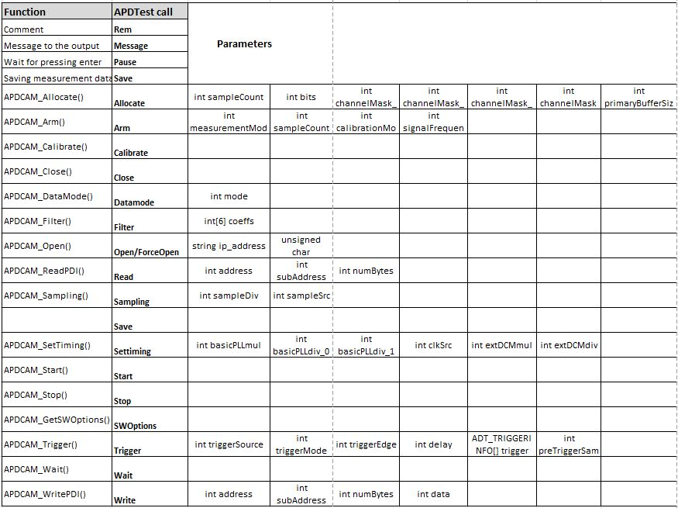
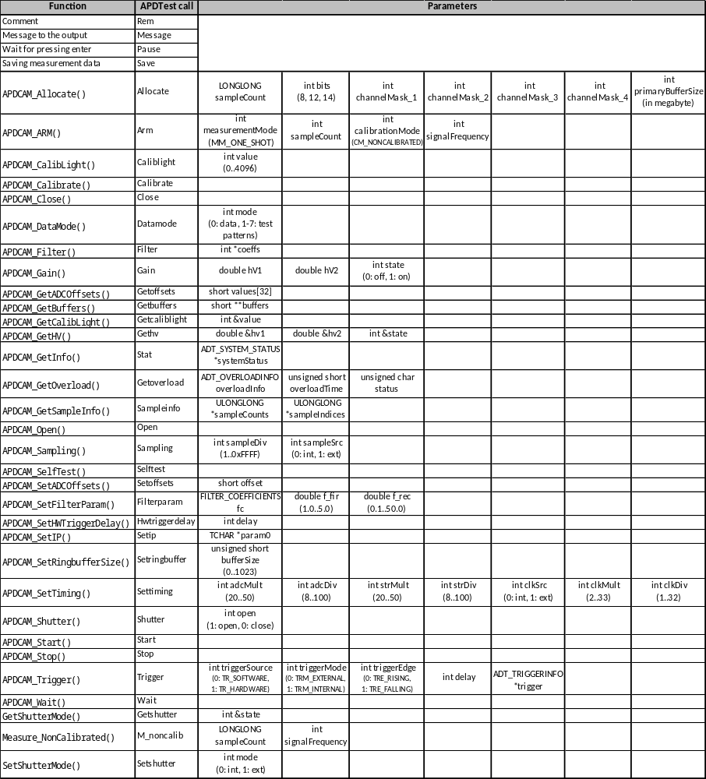

The APDLib library

Initiating and closing APDLib

The library must be initialized before use, and preferably it has to be closed for proper shut down before exiting the application. There are two functions for doing that:

Opening APDLib:
void APDCAM_Init();

Closing APDLib:
void APDCAM_Done();

Searching for APDCAMs in an IP address range

The APD Camera must be opened before use. For this its IP address has to be known. To find APDCAMs in an address range, use the APD_Find() function. This function scans a certain address range and returns the addresses of cameras in that range.

void APDCAM_Find(unsigned long from_ip_h, unsigned long to_ip_h, unsigned long *ip_table, int table_size, int *no_of_elements, char *filter_str = NULL, int timeout = 50);

Parameters:
unsigned long from_ip_h The starting address of the range.
unsigned long to_ip_h The end address of the range.
unsigned long *ip_table The address of the resulting table. (Supplied by the caller.)
int table_size The size of the IP_table table.
int *no_of_elements The number of boards, found. Set by the function.
char *filter_str Filter to find an IP in the IP table, in case of one IP address or to scan all IP addresses in the range use “*” or NULL
int timeout Time limit in milliseconds, until the function waits for the answer from a board. The default is 50ms.

The function requires the IP addresses in an unsigned long, so-called „host” format. This format is „little-endian” on the Intel based computers. (That means, the least significant byte is stored in the lowest address.) The TCP/UDP protocol uses „big-endian” format. That is the so called „network” format. The socket functions require addresses in that format. E.g. the

unsigned long ip_n = inet_addr("10.123.13.101");
returns the address in „network” format. To convert it into „host” format use the
unsigned long ip_h = ntohl(ip_n);
function.
For TCP/UDP ports there are two formats too: „host” and „network” formats. The APDLib function parameters always use „host” format. We indicate this with the postfix _h in the parameter names. (For network format: _n)

Opening and closing APDCAM

APDCAM must be opened before and closed after using it. For that, use the

ADT_HANDLE APDCAM_Open(unsigned long ip_h, unsigned char openMode=0);
ADT_RESULT APDCAM_Close(ADT_HANDLE handle);

functions.

Parameters:
unsigned long ip_h The IP address of the camera.
unsigned char openMode Open mode of the camera, 0 is the default and it means normal open, 1 means force open which doesn’t make board version checks and factory table checks. Force open mode is usually used when APDCAM is not reachable with normal open or factory table does not valid.

Return value: 0,1,2 or handle.

On error, APDCAM_Open() returns 0, 1 or 2 else it returns a handle value, which identifies the camera in the further operations.
Error codes:
0: Register reading error
1: Could not find ADC board version in factory table
2: Could not find Control card version in factory table
The following code extract demonstrates the use of APDCAM_Find and APDCAM_Open.

int main(int argc, char* argv[])
{
APDCAM _Init();

unsigned long ip_n = inet_addr("10.123.13.101");
if (ip_n == INADDR_NONE) return 0;

unsigned long ip_h = ntohl(ip_n);

unsigned long ip_table[32];
int no_of_elements;
APDCAM_Find(ip_h, ip_h+10, ip_table, 32, &no_of_elements, "*");

if (no_of_elements > 0)
{
printf("%d board found,\n", no_of_elements);
ADT_HANDLE handle = APDCAM_Open(ip_table[0]);
if (handle == 0)
{
cout << “Could not open APDCAM” << endl;
APDCAM_Close(handle);
}
else if (handle == 1)
{
cout << “Could not find ADC board version in factory table” >> endl;
APDCAM_Close(handle);
}
else if (handle == 2)
{
cout << “Could not find Control board version in factory table” >> endl;
APDCAM_Close(handle);
}

}

APDCAM _Done();

return 0;
}

Self test

APDCAM can run a test procedure to verify major functionality. After checking a few internal registers this function performs a short measurement with an ADC test pattern. The function uses the first test pattern of APDCAM_DataMode().

ADT_RESULT APDCAM_SelfTest(ADT_HANDLE handle, int mode)

Parameters:
ADT_HANDLE handle The handle value returned by the APDCAM_Open() function.

Return value:
ADT_OK Self test OK.

Changing the IP address of the camera

The IP address of the camera can be changed with the

ADT_RESULT APDCAM_SetIP(ADT_HANDLE handle, unsigned long ip_h)
function.

Parameters:
ADT_HANDLE handle The handle value returned by the APDCAM_Open() function.
unsigned long ip_h IP address in host format.
Return value:
ADT_OK IP address is successfully changed.
ADT_ERROR Error in changing IP address.

Note: If the IP address of the camera is changed note it on the backplate label. If the camera IP address is lost it can be reset to the factory default (10.123.13.101) by switching the camera on while the depressed reset button is pressed with a pointed device. On the next switch-on the IP address and all other camera parameters are reset to factory default. After this the camera needs to be initialized to the APDinit program and the camera configuration file.

Setting the ADC timing

To set the timings of APD Camera, use the

ADT_RESULT APDCAM_SetTiming(ADT_HANDLE handle, int adcMult, int adcDiv, int strMult, int strDiv, int clkSource, int clkMult, int clkDiv);

function.

Parameters:
ADT_HANDLE handle The handle value returned by the APDCAM_Open() function.

int adcMult, int adcDiv The multiplier and divider of ADC PLL respectively. In the case of negative value, the previous settings are used.
Values: 20 ≤ adcMult ≤ 50
8 ≤ adcDiv ≤ 100

int strMult, int strDiv The multiplier and divider of Stream PLL respectively. In the case of negative value, the previous settings are used. Use strMult=30, strDiv=10 as default, change only in special circumstances.
Values: 20 ≤ strMult ≤ 50
8 ≤ strDiv ≤ 100

int clkSource Clock source. 0: internal, 1: external. In the case of negative value, the previous settings are used.

int clkMult, int clkDiv The multiplier and divider of Clock PLL respectively. In the case of negative value, the previous settings are used.
Values: 2 ≤ clkMult ≤ 33
1 ≤ clkDiv ≤ 32

Return value:
ADT_OK Operation completed successfully.
ADT_INVALID_HANDLE_ERROR Invalid handle value supplied.
ADT_ERROR The PLLs can not be synthesize the requested frequencies.

For a detailed description of the APDCAM timing scheme see the APDCAM User's Guide. After the call the ADC sampling frequency will be f_{ADC}=20/adcDiv*adcMult [MHz] if internal clock source is used. For external clock 20 MHz is replaced by f_{ext}*clkMult/clkDiv.

The final sampling rate of APDCAM can be set by the

ADT_RESULT APDCAM_Sampling(ADT_HANDLE handle, int sampleDiv, int sampleSrc);

function.

Parameters:
ADT_HANDLE handle The handle value returned by the APDCAM_Open() function.
int sampleDiv The value of Sample Clock Divider. Only each sampleDiv/th sample will be transmitted from APDCAM.
1 ≤ sampleDiv ≤ 0xFFFF
int sampleSrc The source of sample clock. 0: internal, 1: external.

Return value:
ADT_OK Operation succeeded.
ADT_INVALID_HANDLE_ERROR Invalid handle value supplied.

Setting the signal offsets

APDCAM has a sensitive amplifier and high-gain APD detector. Such a system is prone to offset drifts as a function of temperature and bias voltage. This can be compensated for digitally by shifting the signals through a DAC. For a standard 1 MHz APDCAM offsets around 800 are reasonable values, for special versions different values should be used. The DAC value is unrelated to the measured values. The function for setting the offset is:

ADT_RESULT APDCAM_SetADCOffsets(ADT_HANDLE handle, short *values)

Parameters:
ADT_HANDLE handle The handle value returned by the APDCAM_Open() function.
short *values Array with 32 elements which contains the offset values. (0...4096)

Return value:
ADT_OK Operation succeeded.
ADT_INVALID_HANDLE_ERROR Invalid handle value supplied.
ADT_ERROR Error in setting values.

The offsets can be read back with the

ADT_RESULT APDCAM_GetADCOffsets(ADT_HANDLE handle, short *values)
function.

Parameters:
ADT_HANDLE handle The handle value returned by the APDCAM_Open() function.
short *values The offset values will be loaded to this array.

Return values:
ADT_OK Operation succeeded.
ADT_INVALID_HANDLE_ERROR Invalid handle value supplied.
ADT_ERROR Error in loading values to the array.

Calibrating the offset

The APDCAM_Calibrate function performs an automatic calibration process. It closes the shutter and with successive approximation sets the ADC offsets so as the measured values are close to the lower measurement limit.

ADT_RESULT APDCAM_Calibrate(ADT_HANDLE handle);

Parameters:
ADT_HANDLE handle The handle value returned by the APDCAM_Open() function.

Return values:
ADT_OK Operation succeeded.
ADT_INVALID_HANDLE_ERROR Invalid handle value supplied.

Setting up the digital filter
There is a 5 stage digital filter on the ADC board inside the camera, which connects directly to the output of AD converter. (The a detailed description of the digital filter see the APDCAM User's Guide.) To setup the filter parameters, use the

ADT_RESULT APDCAM_SetFilter(ADT_HANDLE handle, FILTER_COEFFICIENTS filterCoefficients)

function.

Parameters:
ADT_HANDLE handle The handle value returned by the APDCAM_Open() function.
filterCoefficients Filter parameters (structure), see below.

Return values:
ADT_OK Operation succeeded.
ADT_INVALID_HANDLE_ERROR Invalid handle value supplied.
ADT_ERROR Error in setting filter parameters.

The filterCoefficients structure has the following format:

typedef struct FILTER_COEFFICIENTS
{
short FIR[5];
short RecursiveFilter;
short Reserved;
short FilterDevideFactor;
};

Allocating memory for measurements
Before starting measurement, you have to allocate memory for storing data. First you have to be familiar with the working of measurement.
The APD Camera sends the required quantity of data when the measurement starts, or the trigger event occurs.
To Allocate memory use the

ADT_RESULT APDCAM_Allocate(ADT_HANDLE handle, long long sampleCount, int bits, int channelMask_1, int channelMask_2, int channelMask_3, int channelMask_4, int primary_buffer_size = 100);

function.

Parameters:
ADT_HANDLE handle The handle value returned by the APDCAM_Open() function.
long long sampleCount The size of requested memory per channels, measured in samples. In the case of negative value, the system uses the value, previously set. (1)
int bits Resolution. Possible values 8,12,14 bit. In the case of negative value, the system uses the value, previously set. (2)
int channelMask_1 Enable bits of 1st stream (1-8 channels). Channel 1 is the bit 0, etc. In the case of negative value, the system uses the value, previously set. (2)
int channelMask_2 Enable bits of 2nd stream (9-16 channels). Channel 9 is the bit 0, etc. In the case of negative value, the system uses the value, previously set. (2)
int channelMask_3 Enable bits of 3rd stream (17-24 channels). Channel 17 is the bit 0, etc. In the case of negative value, the system uses the value, previously set. (2)
int channelMask_4 Enable bits of 4th stream (25-32 channels). Channel 25 is the bit 0, etc. In the case of negative value, the system uses the value, previously set. (2)
int primary_buffer_size The size of primary buffer, in %, the default value is 100.

Notes:
(1) The values are preserved on the board, until the power supply is on. Switching of the power, the values are lost.
(2) The values are preserved, independently of the power supply switch on/off.

During the period of data acquisition, the data are stored in a primary buffer. A thread evaluates the data to user-friendly format, and stores them in the channel buffers. The last parameter determines the size of the primary buffer, in Megabyte. The default value is 10 MB. The primary buffer size can be increased if data loss occurs.

Return values:
ADT_OK The memory allocation succeeded.
ADT_INVALID_HANDLE_ERROR Invalid handle value supplied.
ADT_PARAMETER_ERROR Parameter error.
ADT_ERROR The memory can not be allocated for any reason.

The addresses of the allocated channel buffers can be obtained with the

ADT_RESULT APDCAM_GetBuffers(ADT_HANDLE handle, short **buffers);

function.

Parameters:
ADT_HANDLE handle The handle value returned by the APDCAM_Open() function.
short **buffers Address of a pointer array. The function fills it with the pointers to the channel buffers. Take care of the size of array, because the function does not check it.

Return values:
ADT_OK Operation completed successfully.
ADT_INVALID_HANDLE_ERROR Invalid handle value supplied.

If you need the index of oldest data in the buffer (this is the beginning of logical buffer.), use the

ADT_RESULT APDCAM_GetSampleInfo(ADT_HANDLE handle, ULONGLONG *sampleCounts, ULONGLONG *sampleIndices);

function, which returns the whole number of received data, and the starting address of logical buffers for the four stream. In normal case the four values are identical.

Parameters:
ADT_HANDLE handle The handle value returned by the APDCAM_Open() function.
ULONGLONG *sampleCount Four element ULONGLONG array, to return the whole number of received data for each stream.
ULONGLONG *sampleIndices Four element ULONGLONG array, to return the indices of oldest data in the channel buffer for each stream.

Return values:
ADT_OK Operation succeeded.
ADT_INVALID_HANDLE_ERROR Invalid handle value supplied.
ADT_PARAMETER_ERROR Parameter error.

Preparing for the measurement

To prepare for the measurement, use the

ADT_RESULT APDCAM_Arm(ADT_HANDLE handle, ADT_MEASUREMENT_MODE mode, LONGLONG sampleCount, ADT_CALIB_MODE calibMode, int signalFrequency = 100);

function.

Parameters:
ADT_HANDLE handle The handle value returned by the APDCAM_Open() function.
ADT_MEASUREMENT_MODE mode Measure certain number of samples or continuous measurement. Its values: MM_ONE_SHOT or MM_CYCLIC respectively. (1)
LONGLONG sampleCount The number of required samples.
ADT_CALIB_MODE calibMode Does nothing in the ADC board. Always use CM_NONCALIBRATED
int signalFrequency The frequency data block processing. default is 100. (2)

Notes:
- At present “MM_CYCLIC” mode is not implemented, only “MM_ONE_SHOT” is available.
- As earlier mentioned, there is a thread, which evaluates primary data and converts them to user friendly form. The thread processes data in blocks. The signal frequency tells the evaluations thread the number of blocks, processed at a time. It default value is 100.

Return values:
ADT_OK Operation completed successfully.
ADT_INVALID_HANDLE_ERROR Invalid handle value supplied.
ADT_ERROR The data receiver could not be started.

The function deletes all trigger conditions. If you want to use any trigger mechanism, you have to set it with the APDCAM_Trigger function.

Setting the trigger conditions

The APDCAM ADC is running all the time, trigger events start the data transmission to the computer. The following function can set the trigger conditions:

ADT_RESULT APDCAM_Trigger(ADT_HANDLE handle, ADT_TRIGGER trigger, ADT_TRIGGER_MODE mode, ADT_TRIGGER_EDGE edge, int triggerDelay, ADT_TRIGGERINFO* triggerInfo, unsigned short preTriggerSampleCount);

Parameters:
ADT_HANDLE handle The handle value returned by the APDCAM_Open() function.
ADT_TRIGGER trigger The trigger can be TR_SOFTWARE: software, or TR_HARDWARE hardware.
ADT_TRIGGER_MODE mode In the case of HW trigger: external or internal. TRM_EXTERNAL: external, TRM_INTERNAL: internal.
ADT_TRIGGER_EDGE edge In the case of external HW trigger the acquisition can be started by the rising or falling edge of trigger signal. Possible values: TRE_RISING, TRE_FALLING
int triggerDelay The data transmission starts after the trigger event with the amount of delay time expressed in units of the base clock period. For internal clock the base clock frequency is 20 MHz. For external clock the external clock PLL settings and the clock period determine the base clock: f_{ext}/ext_div*ext_mul

ADT_TRIGGERINFO *triggerInfo In the case of internal HW or SW trigger, the trigger conditions for each channel. (1)

unsigned short preTriggerSampleCount number of samples stored before trigger(0..1023)

Return value:
ADT_OK Operation succeeded.
ADT_INVALID_HANDLE_ERROR Invalid handle value supplied.
ADT_SETUP_ERROR The function is called before APDCAM_ARM(), or error in trigger setup.

Notes:
(1) triggerinfo is a 32 elements array of type ADT_TRIGGERINFO, one element for each channel. An element sets the trigger condition for the corresponding channel. There are three members in the ADT_TRIGGERINFO structure:

TriggerLevel Trigger level. Its value range depends on the resolution. It can be: 0..255 (for 8 bit), 0..4095 (for 12 bit), 0..16383 (for 14 bit)
Sensitivity Sensitivity. 0: the trigger event occurs when the measured value is below the trigger level. 1: the trigger event is when the measured value is above the trigger level. This trigger is not edge but level controlled.
Enable Enable trigger event in the corresponding channel.

APDCAM data transmission starts when any of the trigger events occur.

The measurement
When the system is ready to start the measurement (conditions are set, memory is allocated, APDCAM_Arm() returned successfully and the trigger conditions are set – if necessary), use the

ADT_RESULT APDCAM_Start(ADT_HANDLE handle);

function. The function returns immediately. This does not mean, that the acquisition is finished. The data acquisition runs in the background, and you can check its state with the APDCAM_Wait() function, described later.

Parameters:
ADT_HANDLE handle The handle value returned by the APDCAM_Open() function.

Return values:
ADT_OK The data acquisition started successfully.
ADT_INVALID_HANDLE_ERROR Invalid handle value supplied.

The completion of measurement can be checked (or wait for) with the

ADT_RESULT APDCAM_Wait(ADT_HANDLE handle, int timeout);

function. If the measurement completed during the timeout interval, the function stops the measurement.

Parameters:
ADT_HANDLE handle The handle value returned by the APDCAM_Open() function.
int timeout Waiting time in milliseconds. –1 means infinite waiting time. 0 value can be used to check the state of measurement.

Return values:
ADT_OK The measurement completed.
ADT_INVALID_HANDLE_ERROR Invalid handle value supplied.
ADT_TIMEOUT The measurement has not been completed yet.
ADT_ERROR The measurement has not been started, or other error occurred.

The measurement can be stopped with the

ADT_RESULT APDCAM_Stop(ADT_HANDLE handle);

function.

Parameters:
ADT_HANDLE handle The handle value returned by the APDCAM_Open() function.

Return values:
ADT_OK Operation succeeded.
ADT_INVALID_HANDLE_ERROR Invalid handle value supplied.
ADT_ERROR The measurement has not been started, or other error occurred.

Shutter control
The shutter can be opened and closed with the

ADT_RESULT APDCAM_Shutter(ADT_HANDLE handle, int open);

function.

Parameters:
ADT_HANDLE handle The handle value returned by the APDCAM_Open() function.
int open 1 opens, 0 closes the shutter.

Return values:
ADT_OK Operation succeeded.
ADT_INVALID_HANDLE_ERROR Invalid handle value supplied.
ADT_PARAMETER_ERROR int open is not 0 or 1.
ADT_ERROR External shutter control is set or error in open/close.

Shutter control can be external or internal, this option can be set with the

ADT_RESULT SetShutterMode(ADT_HANDLE handle, int mode)
function and can be read back with the

ADT_RESULT GetShutterMode(ADT_HANDLE handle, int *mode)
function.
Parameters:
ADT_HANDLE handle The handle value returned by the APDCAM_Open() function.
int mode SetShutterMode(): 0: internal, 1: external.
GetShutterMode(): Integer where the current setting will be loaded to.

Return values:
ADT_OK Operation succeeded.
ADT_INVALID_HANDLE_ERROR Invalid handle value supplied.
ADT_PARAMETER_ERROR int mode is not 0 or 1 in case of SetShutterMode().
ADT_ERROR Error in set or get shutter mode.

Calibration light control
There is a calibration LED in the APD camera, which can be used to check detector. The current of the LED is controlled with the

ADT_RESULT APDCAM_SetCalibLight(ADT_HANDLE handle, int value);

function.

Parameters:
ADT_HANDLE handle The handle value returned by the APDCAM_Open() function.
int value Its value can be in the 0-4095 range. 0 switches off the LED.

Return values:
ADT_OK Operation succeeded.
ADT_INVALID_HANDLE_ERROR Invalid handle value supplied.
ADT_PARAMETER_ERROR int value is not between 0 and 4095.
ADT_ERROR Error in calibration light setting.

The value of the calibration light can be read back with the

ADT_RESULT APDCAM_GetCalibLight(ADT_HANDLE handle, int *value);

function.

Parameters:
ADT_HANDLE handle The handle value returned by the APDCAM_Open() function.
int *value Integer where the current setting will be loaded to.

Return values:
ADT_OK Operation succeeded.
ADT_INVALID_HANDLE_ERROR Invalid handle value supplied.
ADT_ERROR Error in reading settings.

Setting and monitoring the detector bias voltage

ADT_RESULT APDCAM_SetHV(ADT_HANDLE handle, double highVoltage1, double highVoltage2, int state);

Parameters:
ADT_HANDLE handle The handle value returned by the APDCAM_Open() function.
double highVoltage1 1st detector bias voltage in volts. Should be set between 200 and 400 V.
double highVoltage2 2nd detector bias voltage in volts. (Not used in standard APDCAM).
int state 0 switches off, 1 switches on the detector bias voltage.

Return values:
ADT_OK Operation succeeded.
ADT_INVALID_HANDLE_ERROR Invalid handle value supplied.
ADT_PARAMETER_ERROR One or more parameters are not correct.
ADT_FACTORY_SETUP_ERROR Empty factory table.
ADT_ERROR Error in setting voltages and/or state.

The output of high voltage generators are connected to internal ADCs, which are calibrated in the factory. So, the real voltages can be read back from the camera. To get that voltages, use the

ADT_RESULT APDCAM_GetHV(ADT_HANDLE handle, double &highVoltage1, double &highVoltage2, int &state)
function.

Parameters:
ADT_HANDLE handle The handle value returned by the APDCAM_Open() function.
double &highVoltage1, These double variables will contain the voltages.
double &highVoltage2
int &state Integer for getting the state of bias voltage.

Return values:
ADT_OK Operation succeeded.
ADT_INVALID_HANDLE_ERROR Invalid handle value supplied.
ADT_FACTORY_SETUP_ERROR Empty factory table.
ADT_ERROR Error in reading voltages and/or state.

Setting and controlling the detector temperature

The peltier parameters can be set using this function

ADT_RESULT APDCAM_SetPeltierControl(ADT_HANDLE handle, APDPeltierControl apdPeltierControl);

Parameters:
ADT_HANDLE handle The handle value returned by the APDCAM_Open() function.

APDPeltierControl apdPeltierControl Peltier settings structure

Return values:
ADT_OK Operation succeeded.
ADT_ERROR

The APDPletierControl structure:

struct APDPeltierControl
{
short indirectPeltierControl;
unsigned short pGain;
unsigned short iGain;
unsigned short dGain;
bool disablePIDControl;
};

The peltier parameters can be read using this function

ADT_RESULT APDCAM_GetPeltierControl(ADT_HANDLE handle, APDPeltierControl *apdPeltierControl);

Parameters:
ADT_HANDLE handle The handle value returned by the APDCAM_Open() function.

APDPeltierControl *apdPeltierControl Peltier settings structure

Return values:
ADT_OK Operation succeeded.
ADT_ERROR Error in getting parameters

The detector reference temperature can be set using this function:

ADT_RESULT APDCAM_SetDetectorReferenceTemp(ADT_HANDLE handle, short referenceTemp);

Parameters:
ADT_HANDLE handle The handle value returned by the APDCAM_Open() function.

short referenceTemp Detector reference temperature in Celsius

Return values:
ADT_OK Operation succeeded.
ADT_ERROR

The detector reference temperature can read set using this function:

ADT_RESULT APDCAM_GetDetectorReferenceTemp(ADT_HANDLE handle, short *referenceTemp);

Parameters:
ADT_HANDLE handle The handle value returned by the APDCAM_Open() function.

short *referenceTemp Detector reference temperature in Celsius

Return values:
ADT_OK Operation succeeded.
ADT_ERROR Error in setting voltages and/or state.

Setting and monitoring analog panel power

The analog panel power can be switched on and off with the following function

ADT_RESULT APDCAM_SetAnalogPower(ADT_HANDLE handle, bool enable);

Parameters:
ADT_HANDLE handle The handle value returned by the APDCAM_Open() function.

bool enable If true the analog power will switch on, if false the analog power will be switched off.

Return values:
ADT_OK Operation succeeded.
ADT_ERROR

The analog panel power state can read with the following function

ADT_RESULT APDCAM_GetAnalogPower(ADT_HANDLE handle, bool *enable);

Parameters:
ADT_HANDLE handle The handle value returned by the APDCAM_Open() function.

bool *enable If true the analog power is on, if false the analog power is off.

Return values:
ADT_OK Operation succeeded.
ADT_ERROR

Setting camera fans speed

APDCAM fans speed can be controlled using this function

ADT_RESULT APDCAM_SetFansSpeed(ADT_HANDLE handle, unsigned char fan1Speed, unsigned char fan2Speed, unsigned char fan3Speed );

Parameters:
ADT_HANDLE handle The handle value returned by the APDCAM_Open() function.

unsigned char fan1Speed Speed value of fan1 can be between 0 and 255.

unsigned char fan2Speed Speed value of fan2 can be between 0 and 255.

unsigned char fan3Speed Speed value of fan3 can be between 0 and 255.

Return values:
ADT_OK Operation succeeded.
ADT_ERROR

Setting the overload protection
The overload protection circuit switches off the detector bias voltage when the signal is above a certain level for a certain time. The parameters can be set with the

ADT_RESULT APDCAM_SetOverload(ADT_HANDLE handle, ADT_OVERLOADINFO overloadInfo, unsigned short overloadTime)

function.

Parameters:
ADT_HANDLE handle The handle value returned by the APDCAM_Open() function.
ADT_OVERLOADINFO overloadInfo Structure for the overload parameters.
unsigned short overloadTime Overload protection time.

Return values:
ADT_OK Operation succeeded.
ADT_INVALID_HANDLE_ERROR Invalid handle value supplied.
ADT_ERROR Error in setting parameters and/or time.

overloadInfo:

typedef union ADT_OVERLOADINFO
{
unsigned short OverloadInfo;
struct
{
unsigned short level : 14;
unsigned short polarity : 1;
unsigned short enable : 1;
};
};

The overload setting can be read back with the

ADT_RESULT APDCAM_GetOverload(ADT_HANDLE handle, ADT_OVERLOADINFO &overloadInfo, unsigned short &overloadTime, unsigned char &status)

function.

Parameters:
ADT_HANDLE handle The handle value returned by the APDCAM_Open() function.
ADT_OVERLOADINFO &overloadInfo Structure for the overload parameters.
unsigned short &overloadTime Unsigned short for overload time.
unsigned char &status Unsigned char for status. 0: overload off, 1: overload on
Return values:
ADT_OK Operation succeeded.
ADT_INVALID_HANDLE_ERROR Invalid handle value supplied.
ADT_ERROR Error in reading overload protection settings.

Using ADC test pattern

The APD Camera can transmit test sequences, instead of measured data. These can be used to check the data transmission. You can select between data and various test sequences with the

ADT_RESULT APDCAM_DataMode(ADT_HANDLE handle, int modeCode)

function.

Parameters:
ADT_HANDLE handle The handle value returned by the APDCAM_Open() function.
int modeCode Data or test sequence identifier.

The possible values of modeCode:

0 Measurement data
1 10 0000 0000 0000
2 11 1111 1111 1111
3 00 0000 0000 0000
4 10 1010 1010 1010, 01 0101 0101 0101
5 Long pseudo-random. (l. ITU-T 0.150 (05/96) standard
6 Short pseudo-random. (l. ITU-T 0.150 (05/96) standard
7 11 1111 1111 1111, 00 0000 0000 0000

From the above 14 bit patterns APDCAM sends only the upper 8, 12 or 14 bits depending on the bit resolution selected. The values returned in the measurement are calculated from the above numbers (v) the following way:
- For 8 bit resolution: 256-v
- For 12 bit resolution: 4096-v
- For 14 bit resolution: 16384-v
It has to be noted that for the above values uncalibrated data should be measured. For the pseudo random patterns only the samples selected by sampleDiv are transmitted.

Return values:
ADT_OK Operation succeeded.
ADT_INVALID_HANDLE_ERROR Invalid handle value supplied.
ADT_PARAMETER_ERROR int modeCode is not between 0 and 7
ADT_ERROR Error in setting test sequence.

Reading the system status

Basic system infos can be retrieved by the

ADT_RESULT APDCAM_GetInfo(ADT_HANDLE handle, APDInfo *apdInfo);

function.

Parameters:
ADT_HANDLE handle The handle value returned by the APDCAM_Open() function.
APDInfo *apdInfo Address of an APDInfo structure.

Return values:
ADT_OK Operation succeeded.
ADT_INVALID_HANDLE_ERROR Invalid handle value supplied.
ADT_ERROR Error in reading status.

The APDInfo structure:

struct APDInfo
{
//Control card infos
//unsigned short pcBoardSerial;
unsigned char pcBoardVersion;
unsigned short pcFWVersion;

//ADC infos
unsigned char adcBoardVersion;
unsigned short adcMCVersion;
unsigned short adcSerial;
unsigned short fpgaVersion;

};//APDInfo

Basic system status paramters can be retrieved by the

ADT_RESULT APDCAM_GetStatus(ADT_HANDLE handle, APDStatus *apdStatus);

function.

Parameters:
ADT_HANDLE handle The handle value returned by the APDCAM_Open() function.
APDStatus *apdStatus Address of an APDStatus structure.

Return values:
ADT_OK Operation succeeded.
ADT_INVALID_HANDLE_ERROR Invalid handle value supplied.
ADT_ERROR Error in reading status.

The APDStatus structure:

struct APDStatus
{
//Control card status
double highVoltages[4];
double temperatures[16];
double peltierOutputVoltage;
unsigned char fanSpeed[3];
unsigned short calibrationLight;
unsigned char shutterMode;
unsigned char shutterState;

//ADC board status
Status1 status1;
Status2 status2;
Control control;

};//APDStatus

struct Status1
{
bool adcClkPllLocked;
bool streamClkPllLocked;
};

struct Status2
{
bool factoryResetPinState;
bool overLoad;
bool externalClkDcmLocked;
bool ad1SampleEnabled;
bool ad2SampleEnabled;
bool ad3SampleEnabled;
bool ad4SampleEnabled;
};

struct Control
{
bool extClkSelect;
bool eioClkOutEnable;
bool sampleClkSelect;
bool eioSampleOutEnable;
bool filterOn;
bool reserveBitOrderInStream;
bool preamblePatternEnabled;
};

The current camera config paramters can be retrieved by the

ADT_RESULT APDCAM_GetConfig(ADT_HANDLE handle, APDStr *apdStr);

function.

Parameters:
ADT_HANDLE handle The handle value returned by the APDCAM_Open() function.
APDStr *apdStr Address of an APDStr structure.

Return values:
ADT_OK Operation succeeded.
ADT_INVALID_HANDLE_ERROR Invalid handle value supplied.
ADT_ERROR Error in reading status.

The APDStr structure:

struct APDStr
{

int adcMult;
int adcDiv;
int strMult;
int strDiv;
int clkSource;
int clkMult;
int clkDiv;

int sampleDiv;
int sampleSrc;

long long sampleNum;
int bits;
int channelMask1;
int channelMask2;
int channelMask3;
int channelMask4;
//int primaryBufferSize;
//int measMode;
//int calibMode;
//int signalFreq;

int trigSource;
int trigMode;
int trigEdge;
int trigDelay;
TrgInfo trigInfo[32];
unsigned short preTrigSampleCount;

double hv1;
double hv2;
bool hvOn[2];
bool hvEnabled;
bool analogEnable;

short peltierIndirectControl;
short detectorReferenceTemp;
unsigned short pGain;
unsigned short iGain;
unsigned short dGain;
bool disablePIDControl;

unsigned char fanSpeed[3];

unsigned short calibrationLight;
unsigned char shutterMode;
unsigned char shutterState;

short offsets[32];

};

6. Troubleshooting
This section contains some tips what to do when problems occur.

Continuity counter error
This error is indicated by APDTest when missing UDP packages are detected. There are various possible reasons for this:
- Slow or poor network connection. When using high data rates connect a APDCAM and the PC directly using a good quality UTP network cable.
- Too high data rate is set. The maximum sampling rate for 32 channels and 14 bits is 2 MHz. Exceeding this limit will result in data loss on the network connection. If some channels are disabled or the bit resolution is decreased the sampling rate can be proportionally increased.
- PC activity. If too many additional tasks are running on the computer it might result in data loss.
- Poor PC performance. Use modern PCs, quad-core processors are recommended although smaller versions might also work.
- Power save mode is set. Especially on laptops during battery operation the processor speed is limited and/or PCI bus is switched off after some inactivity. Set the minimum processor power at 100% and disable PCI bus switch off.

Missing data (0 values)
If data contains 0 from some point it indicates continuity counter error, see above

Oscillating data or data at minimum/maximum.
The detector HV is not set. The sensitive amplifiers of APDCAM require a minimum HV to be set. Depending on amplifier parameters the minimum HV is typically 150-200 V.

No data but camera communication OK
Check Firewall settings on the PC. Firewalls can detect camera register communication as originating from the PC and will allow it, but they often treat data transmission (which is sent to another port) as attack and throw away communication data without warning.

Program chashes at the allocate call.
Locking memory in physical space is not enabled for the user. See section 2 for setting this feature.

